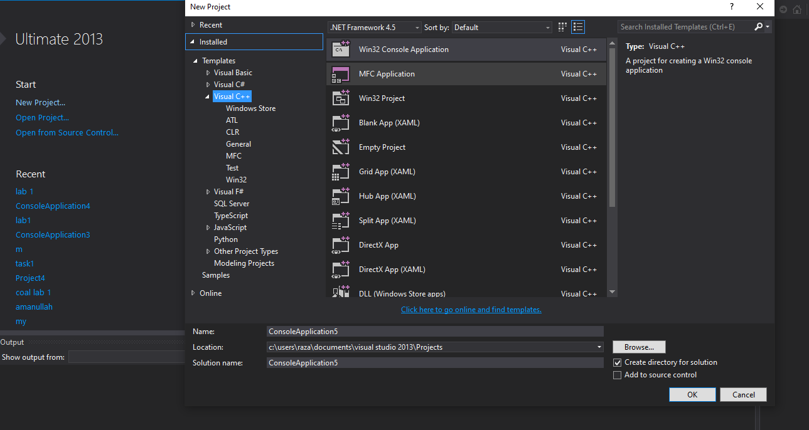

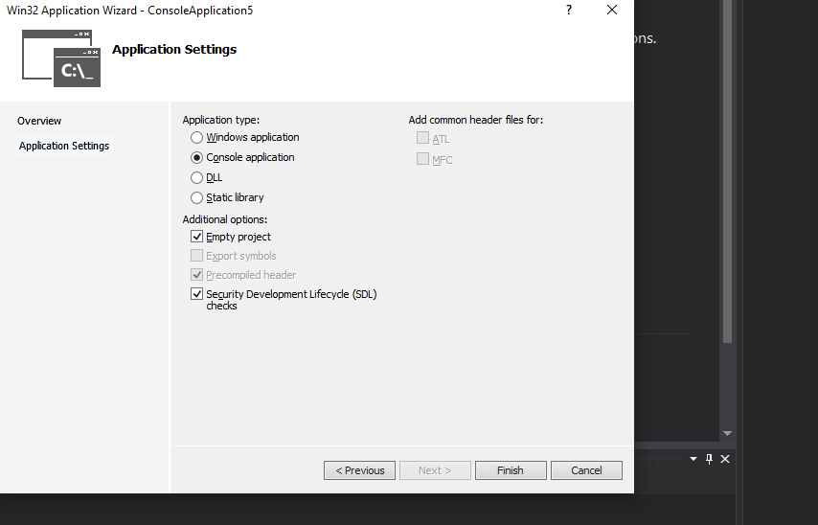

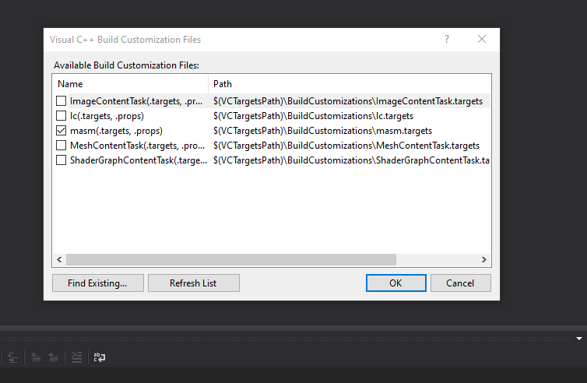

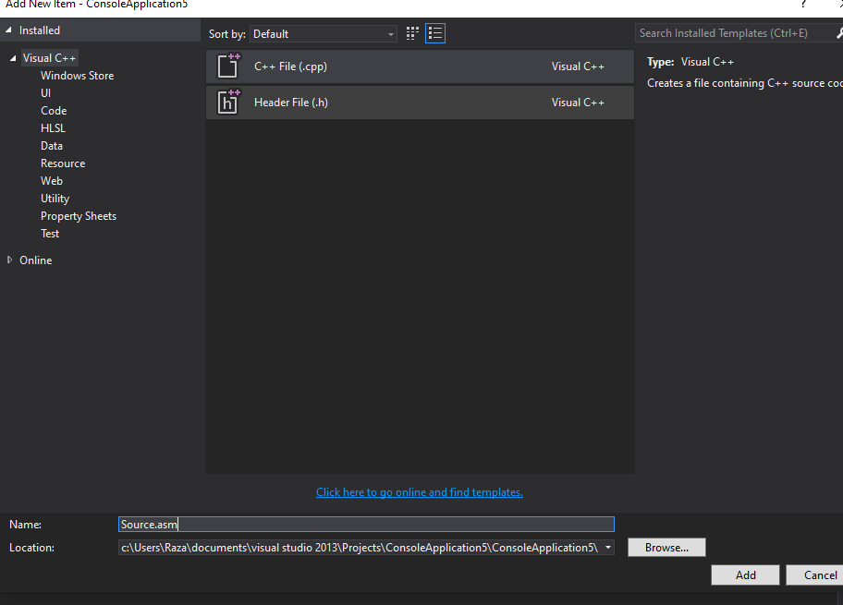

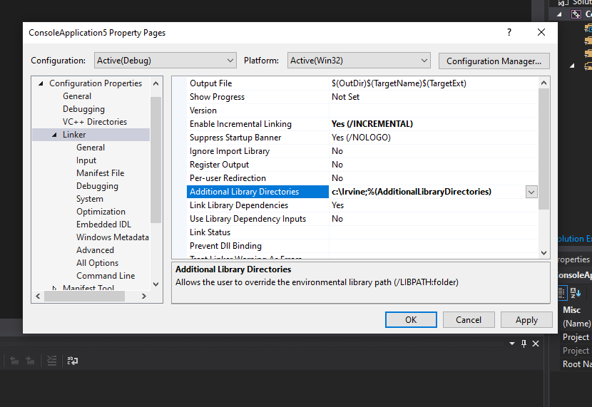

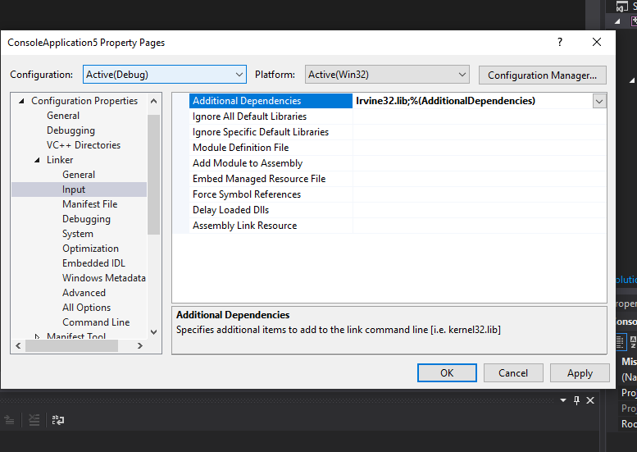

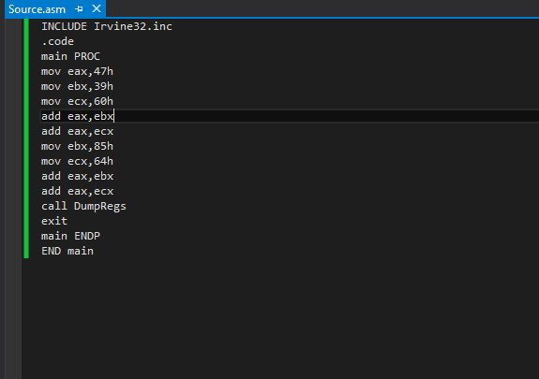

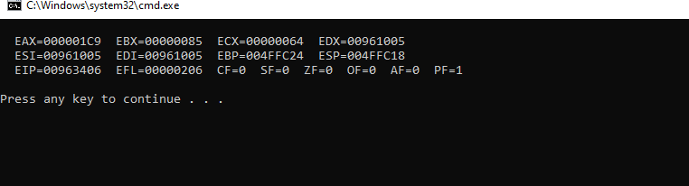

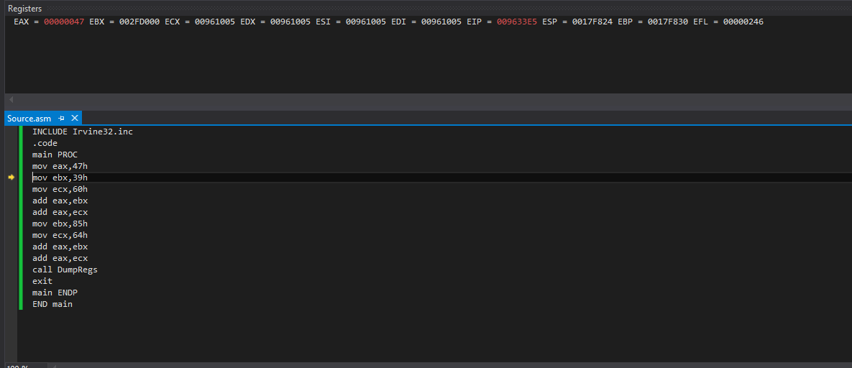

EAX=00000047

EBX=002FD000

ECX=00961005

EDX=00961005

EDI=00961005

EIP=009633E5

ESP=0017F824

EBP=0017F830

EFL=0000246

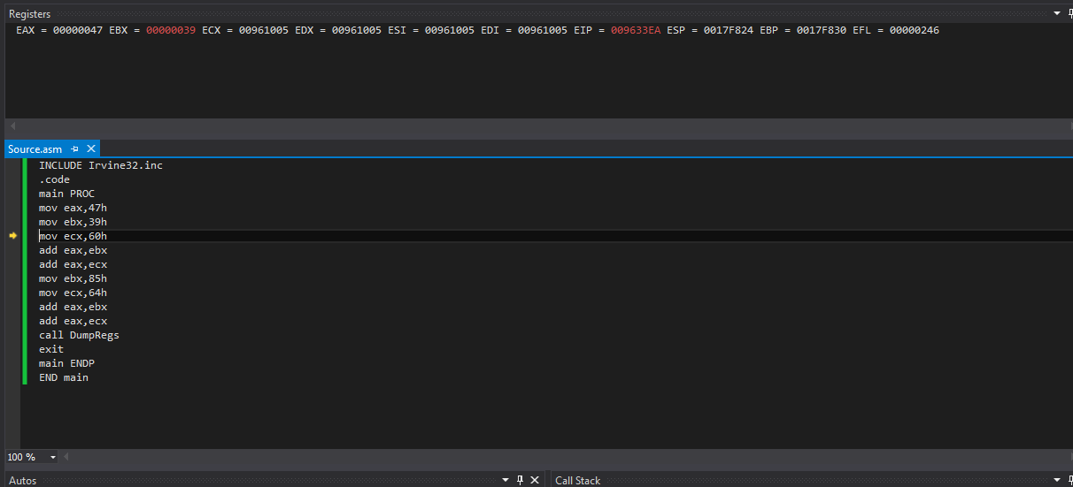

EAX=00000047

EBX=00000039

ECX=00961005

EDX=00961005

EDI=00961005

EIP=009633EA

ESP=0017F824

EBP=0017F830

EFL=0000246

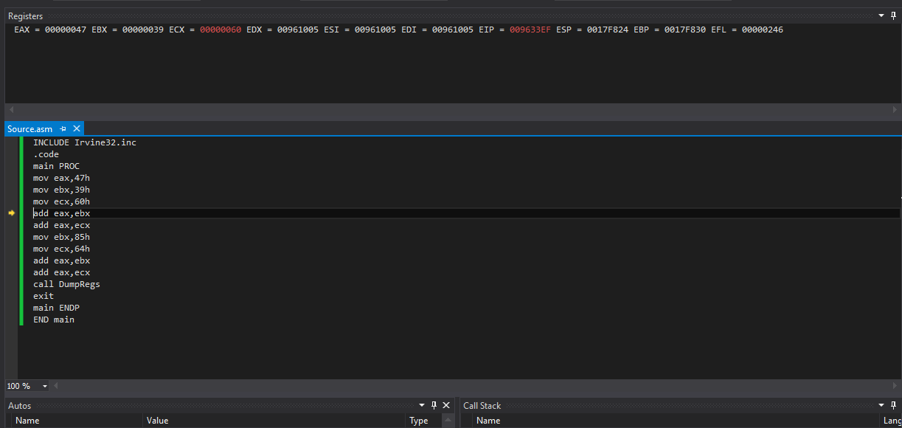

EAX=00000047

EBX=0000039

ECX=00000060

EDX=00961005

EDI=00961005

EIP=009633EF

ESP=0017F824

EBP=0017F830

EFL=0000246

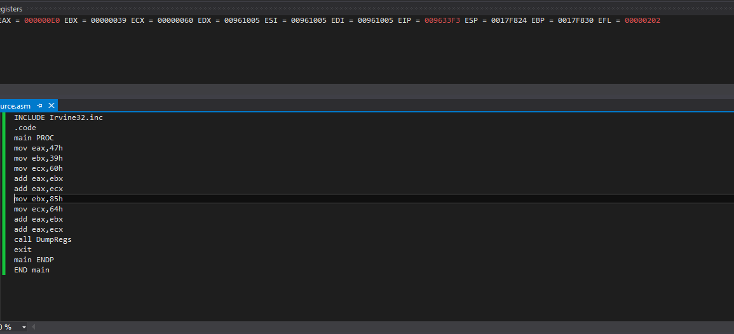

EAX=000000E0

EBX=0000039

ECX=00000060

EDX=00961005

EDI=00961005

EIP=009633F3

ESP=0017F824

EFL=00000202

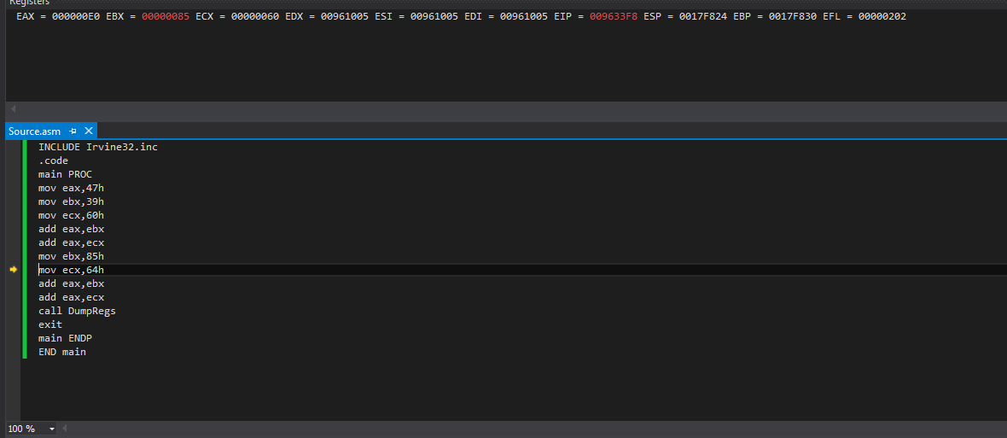

EAX=000000E0

EBX=00000085

ECX=00000060

EDX=00961005

EDI=00961005

EIP=009633F8

ESP=0017F824

EFL=00000202

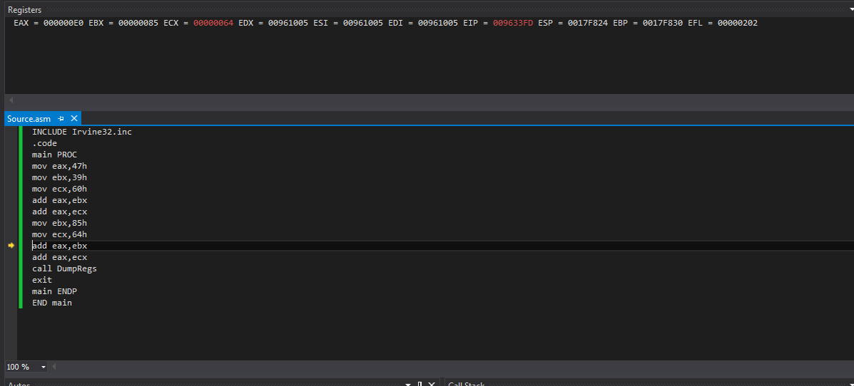

EAX=000000E0

EBX=00000085

ECX=00000064

EDX=00961005

EDI=00961005

EIP=009633FD

ESP=0017F824

EFL=00000202

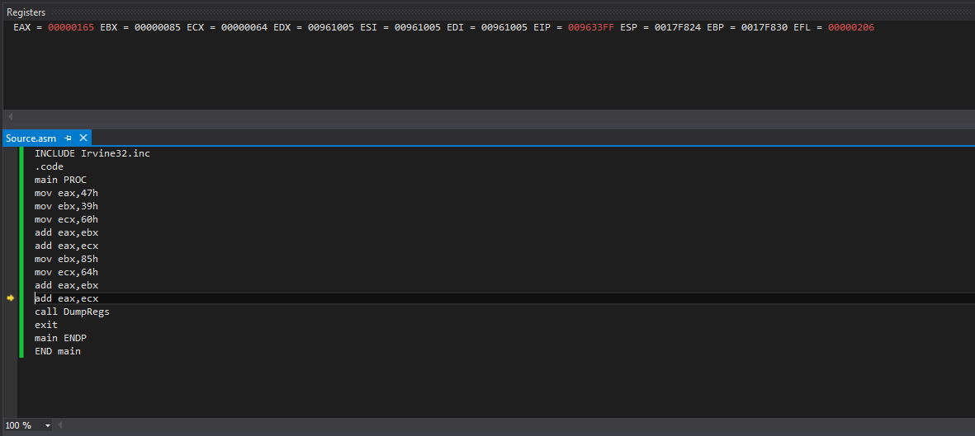

EAX=00000165

EBX=00000085

ECX=00000064

EDX=00961005

EDI=00961005

EIP=009633FF

ESP=0017F824

EFL=00000206